# Evaluation

## Objectives

## Teacher Side

### 1

|  |  |  |
| --- | --- | --- |
| Objective | Criteria | Evaluation |
| Login | Username and password input correctly. Allows access and loads the main teacher form. | SUCCESS  Missing field’s prompted to be filled. Incorrect username or pass word prevents login. Correct username for existing teacher or admin account allows access. |

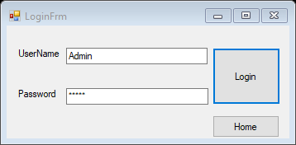

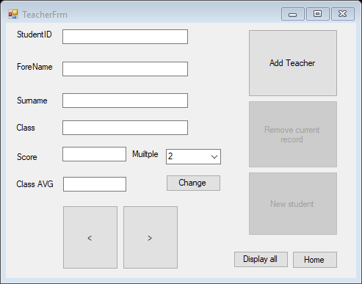

### 2A

|  |  |  |
| --- | --- | --- |
| Objective | Criteria | Evaluation |
| Account Display | Admin account displays all students and individual scores | SUCCESS  All students displayed in text boxes so teacher can scroll through them, and in and data grid view to compare them. |
|  |  |  |

### 2B